Ensemble techniques
Ensemble techniques in machine learning combine multiple individual models to create a more robust and accurate predictive model. This approach leverages the strengths of diverse models and mitigates their individual weaknesses, often leading to better generalization and reduced overfitting.
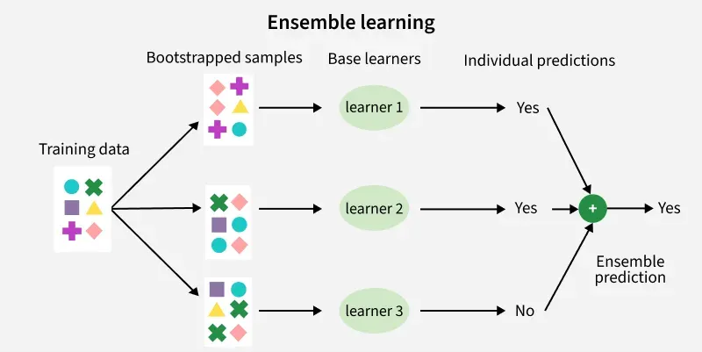
Here's a breakdown of common ensemble methods:
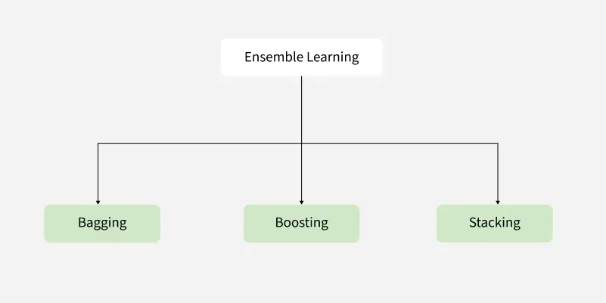
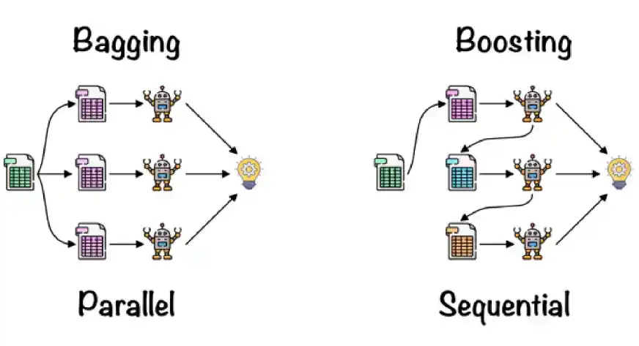
1. Bagging:
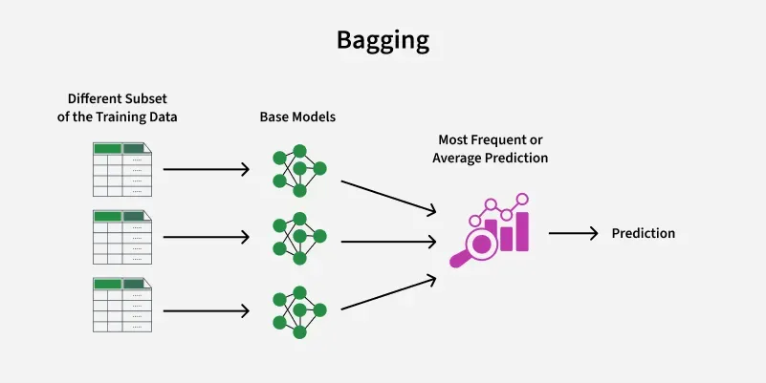
- Concept: Creates multiple models by training on different random subsets (with replacement) of the training data (bootstrap samples).

- Example: Random Forests use bagging with decision trees as base learners.

- Benefit: Reduces variance and improves stability by averaging predictions.
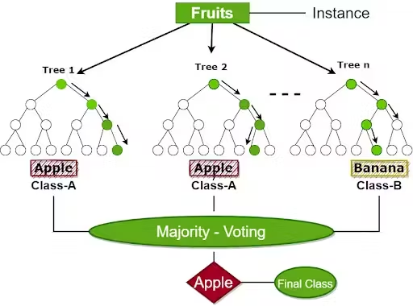
2. Boosting:
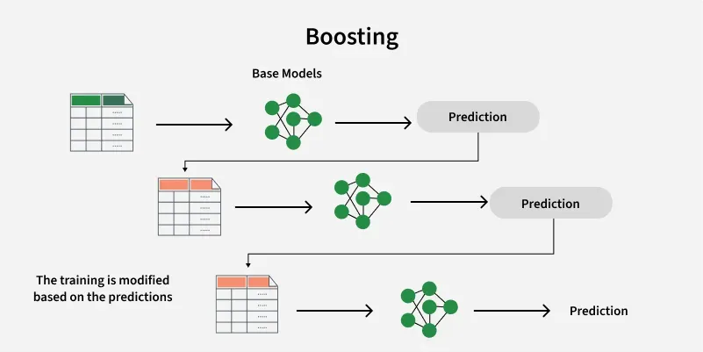
- Concept: Sequentially trains models, with each model focusing on correcting the errors of its predecessors.

- Examples: AdaBoost, Gradient Boosting (GBM), XGBoost, LightGBM.

- Benefit: Reduces bias and can achieve high accuracy, but can be more prone to overfitting if not carefully tuned.

3. Stacking:
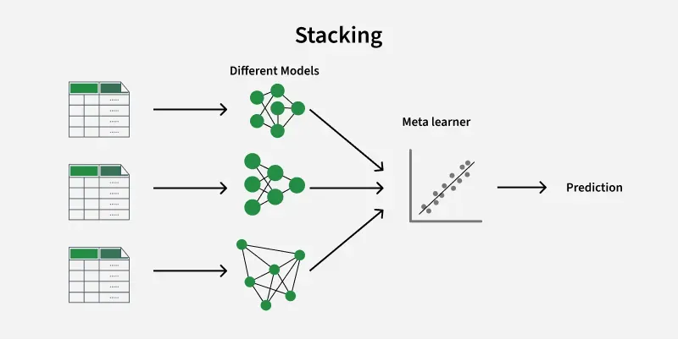
- Concept:
Trains multiple heterogeneous models (using different algorithms) and then uses a meta-model to learn how to best combine their predictions.
- Benefit:
Can capture complex relationships in the data, but is more complex to implement.
4. Voting:
- Concept: Combines predictions from multiple models by taking a majority vote (for classification) or averaging (for regression).

- Benefit: Simple to implement and can improve robustness.

In essence, ensemble methods work on the principle that "many (weak) minds are better than one (strong) mind." By combining the predictions of multiple models, ensemble methods can often achieve better performance than any single model could on its own.
Ensemble learning offers advantages like improved accuracy, robustness, and reduced overfitting, but also drawbacks such as increased computational complexity, reduced interpretability, and potential for overfitting in some cases. It combines multiple base models to create a stronger, more accurate, and more robust final model.
Advantages of Ensemble Learning:
- Improved Accuracy:
Ensemble methods often outperform individual models due to the combination of diverse perspectives.
- Robustness to Outliers:
Ensembles are less susceptible to the influence of outliers compared to single models.
- Reduced Overfitting:
By averaging predictions from multiple models, ensembles can mitigate overfitting, leading to better generalization.
- Improved Generalization:
Ensembles can capture more complex patterns and generalize better to unseen data compared to single models.
- Flexibility:
Ensembles can incorporate various types of base models, allowing for adaptability to diverse problems.

Benefits of Ensemble Learning in Machine Learning
Ensemble learning is a versatile approach that can be applied to machine learning model for: -
- Reduction in Overfitting: By aggregating predictions of multiple model's ensembles can reduce overfitting that individual complex models might exhibit.
- Improved Generalization: It generalizes better to unseen data by minimizing variance and bias.
- Increased Accuracy: Combining multiple models gives higher predictive accuracy.
- Robustness to Noise: It mitigates the effect of noisy or incorrect data points by averaging out predictions from diverse models.
- Flexibility: It can work with diverse models including decision trees, neural networks and support vector machines making them highly adaptable.
- Bias-Variance Tradeoff: Techniques like bagging reduce variance, while boosting reduces bias leading to better overall performance.
Disadvantages of Ensemble Learning:
- Increased Computational Complexity:
Training multiple models and combining their outputs can be computationally demanding.
- Reduced Interpretability:
Ensemble models can be harder to interpret than single models, making it difficult to understand their decision-making process.
- Potential for Overfitting:
While generally less prone to overfitting, certain ensemble techniques like boosting can still overfit if not properly tuned.
- Longer Training Times:
Training and combining multiple models can significantly increase training time.
- Higher Memory Usage:
Storing multiple base models can lead to increased memory consumption.
- Difficulty in Debugging:
Identifying issues in ensemble models can be challenging due to the interactions between multiple base learners.
Here’s the full guide on Ensemble Techniques in Supervised Learning (for both Regression and Classification) including:
- 📘 Definitions
- 🧠 Intuitions
- 🧪 Python Code
- ✅ Advantages & ❌ Disadvantages
- 📈 Use Cases
- 📍 When to Use & Why
- 🚧 Limitations & 🔁 Alternatives

🔧 What is Ensemble Learning?
Ensemble Learning is a method that combines multiple models (often called “weak learners”) to produce a more powerful model.
There are 3 major types:
- Bagging (e.g., Random Forest)
- Boosting (e.g., Gradient Boosting, AdaBoost, XGBoost, LightGBM, CatBoost)
- Stacking (e.g., combining different model types)

🔷 ENSEMBLE MODELS FOR REGRESSION & CLASSIFICATION

Bootstrap Aggregation (Bagging)

Bootstrap Aggregation (or Bagging for short), is a simple and very powerful ensemble method.

✅ 1. Random Forest (Bagging)

📘 Definition:
An ensemble of Decision Trees where each tree is trained on a random subset of data and features (bootstrap aggregating = bagging).
https://scikit-learn.org/stable/modules/generated/sklearn.ensemble.RandomForestClassifier.html

🧠 Intuition:
Reduces overfitting by averaging many uncorrelated trees.


🧪 Code:
from sklearn.ensemble import RandomForestClassifier, RandomForestRegressor

clf = RandomForestClassifier(n_estimators=100) # For classification

reg = RandomForestRegressor(n_estimators=100) # For regression
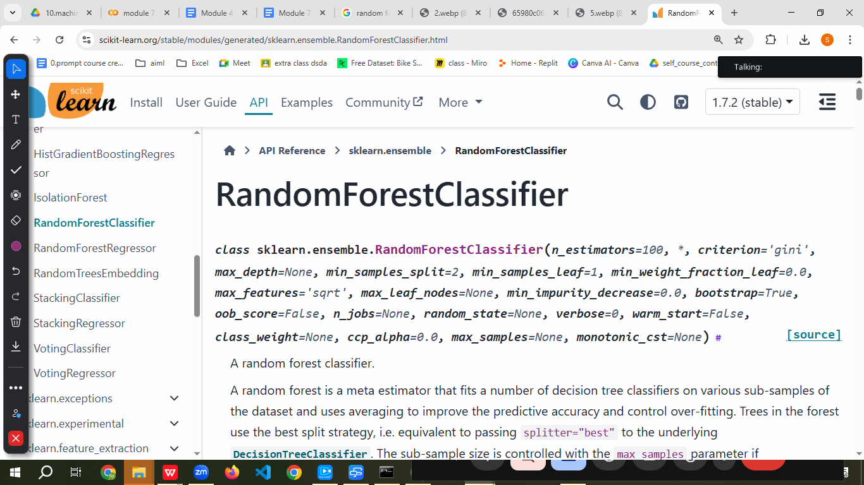
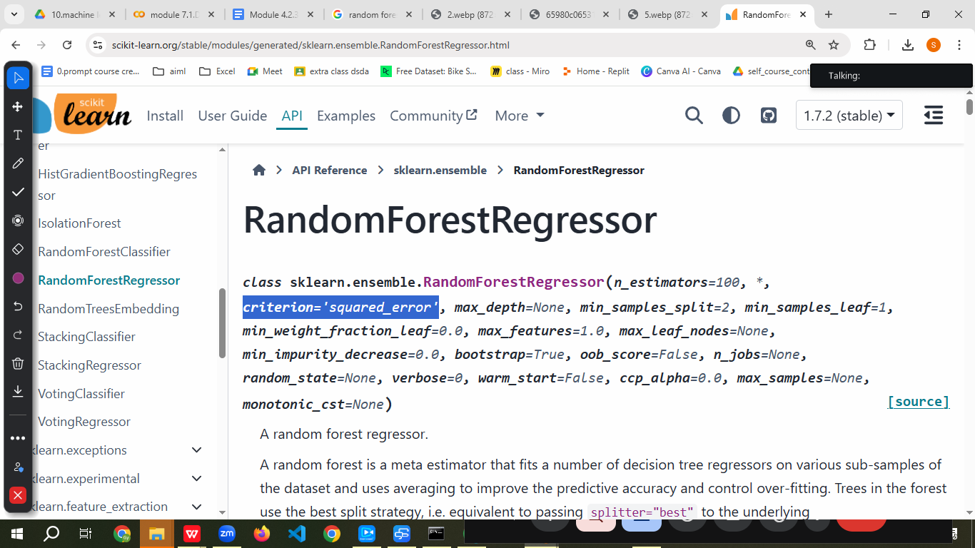

✅ Advantages:
- Reduces variance and overfitting
- Handles missing values
- Works for both regression and classification

❌ Disadvantages:
- Slower than individual trees
- Less interpretable

📈 Use Case:
Fraud detection, house price prediction, medical diagnosis

📍 When to Use:
When data has non-linearity, noise, or many features

🚧 Limitations:
- Less transparent
🔁 Alternative: Use Explainable AI tools (SHAP, LIME) or simpler models

============================================================================================

2. Boosting
================================================

✅ 2. AdaBoost (Adaptive Boosting)

"Adaptive" describes something that has the ability or tendency to change and adjust to suit different situations or changing conditions. It implies flexibility, a willingness to learn, and the capacity to modify behavior, parameters, or forms to thrive in new or altered environments.

Adaptive learning is an educational approach that uses data-driven technology, often artificial intelligence, to customize the learning experience for each individual, rather than using a one-size-fits-all method.

https://www.geeksforgeeks.org/machine-learning/implementing-the-adaboost-algorithm-from-scratch/
https://en.wikipedia.org/wiki/AdaBoost
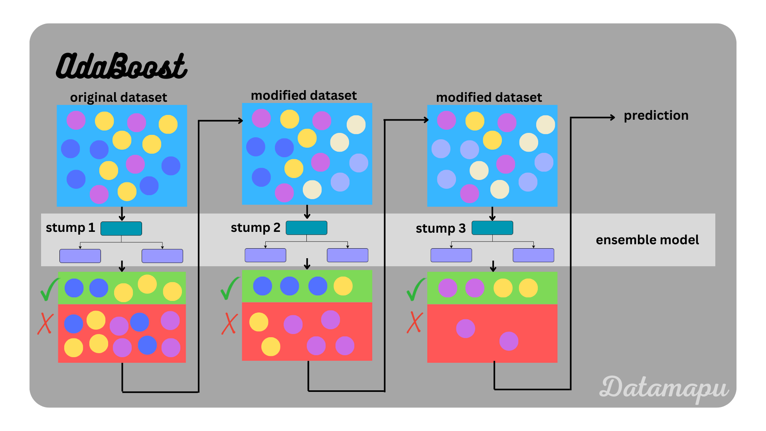
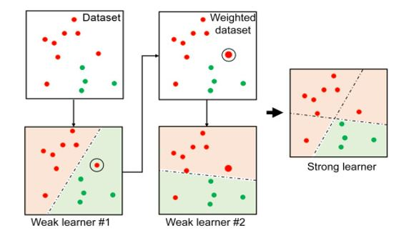

📘 Definition:
Sequentially builds models that focus on the mistakes of previous models, adjusting weights of misclassified instances.

🧠 Intuition:
Each new model tries to correct the errors of the previous one.

🧪 Code:
from sklearn.ensemble import AdaBoostClassifier, AdaBoostRegressor

clf = AdaBoostClassifier(n_estimators=50)
reg = AdaBoostRegressor(n_estimators=50)
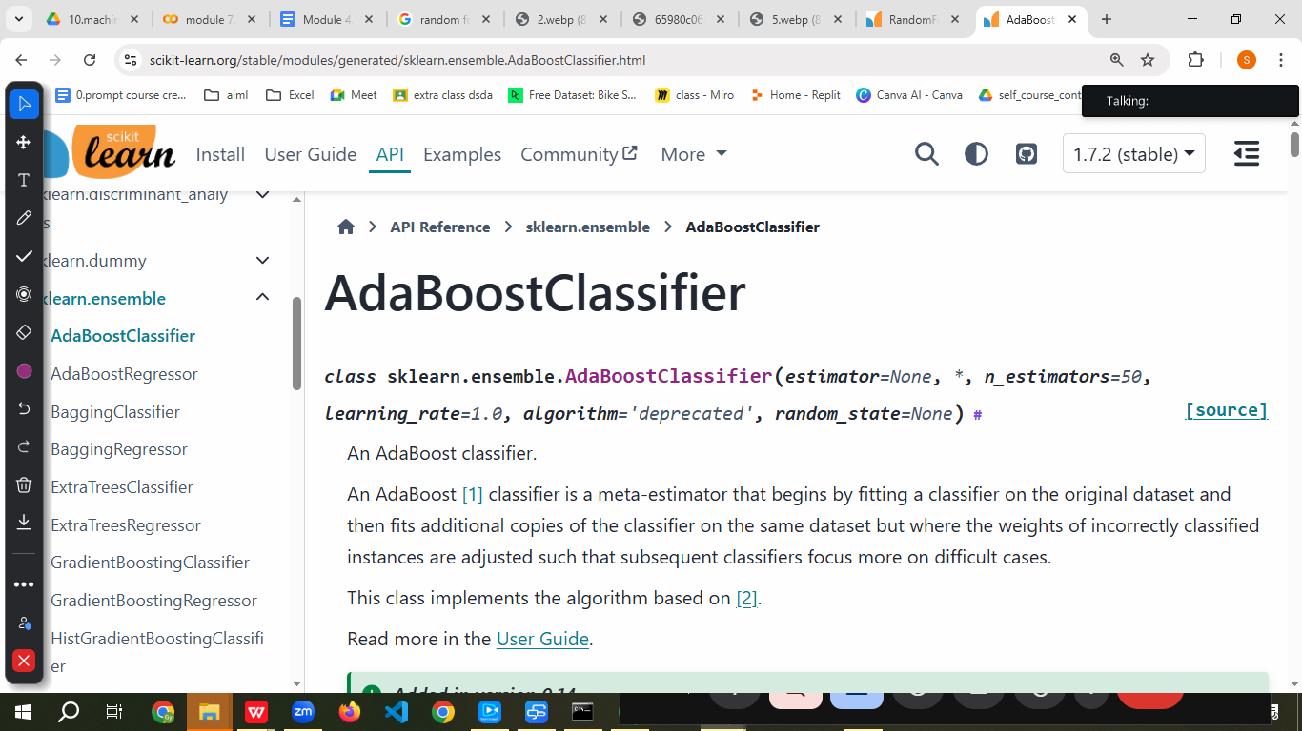
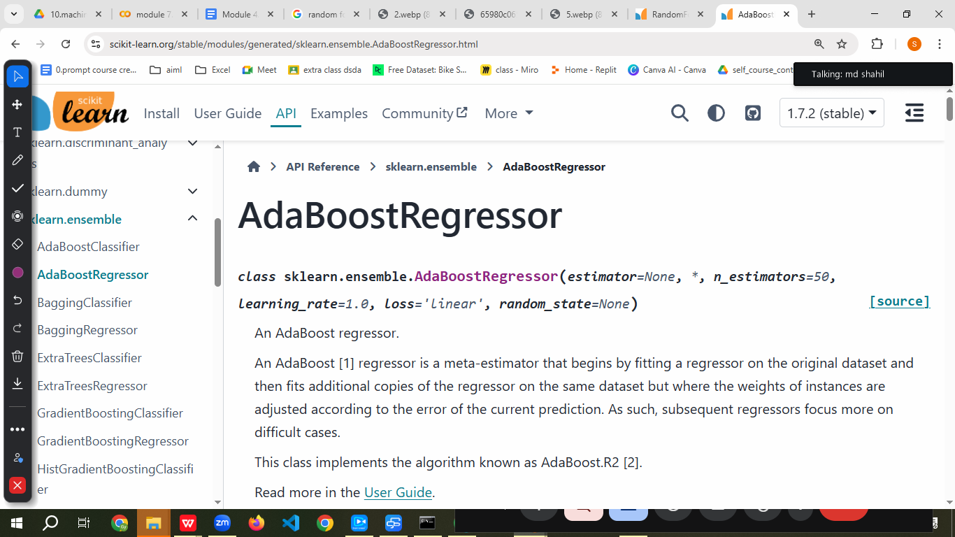

✅ Advantages:
- Simple & effective
- Works well with weak learners (e.g., shallow trees)

❌ Disadvantages:
- Sensitive to outliers
- Can overfit if not tuned

📈 Use Case:
Credit scoring, anomaly detection

📍 When to Use:
When base model is weak and you want to improve it via boosting

🚧 Limitations:
- Struggles with noisy data
🔁 Alternative: Use Gradient Boosting or more robust boosting techniques

✅ 3. Gradient Boosting Machines (GBM)

What Is the Definition of Gradient?
The gradient is the inclination of a line. The gradient is often referred to as the slope (m) of the line. The gradient or slope of a line inclined at an angle θ is equal to the tangent of the angle θ .

Descent → a movement down to a lower place

Gradient descent is an iterative optimization algorithm that minimizes a differentiable function by repeatedly moving in the direction of the steepest decrease, which is the opposite of the gradient. It's widely used in machine learning to find the parameters (weights and biases) that minimize the loss function, thus improving model predictions.
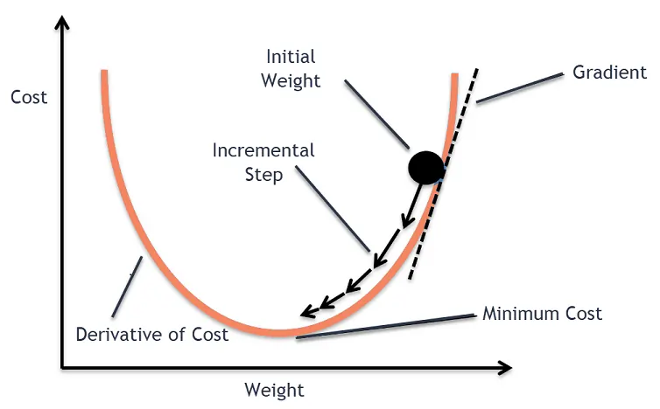

📘 Definition:
Boosting technique that minimizes the loss function using gradient descent.
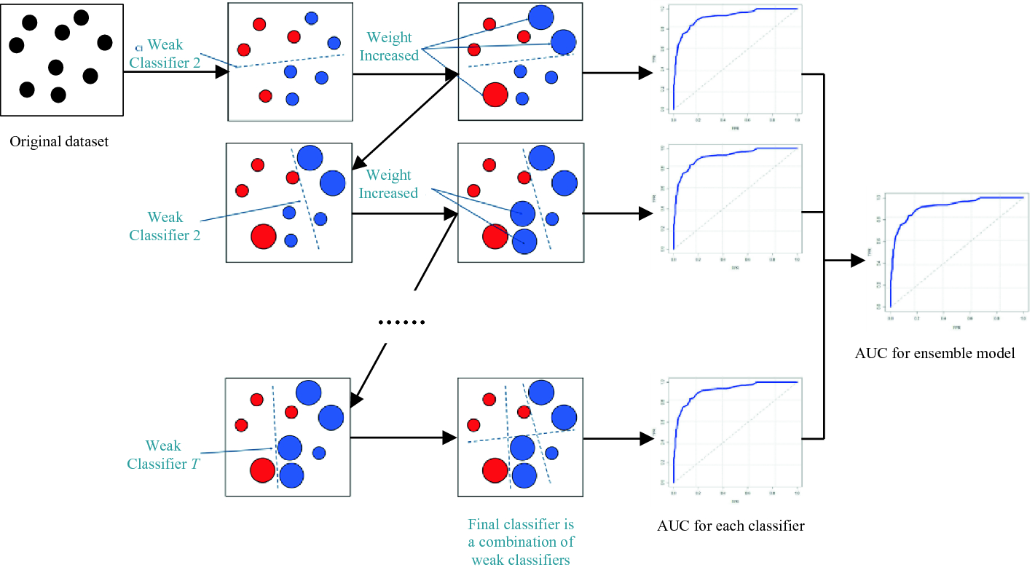
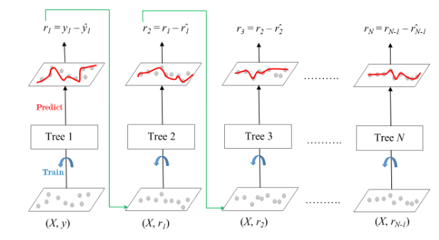
https://medium.com/@ilyurek/gradient-boosting-machines-gbm-with-python-example-b65421d10f2a

🧠 Intuition:
Each tree corrects the residuals (errors) of the previous tree.

🧪 Code:
from sklearn.ensemble import GradientBoostingClassifier, GradientBoostingRegressor

clf = GradientBoostingClassifier()

reg = GradientBoostingRegressor()
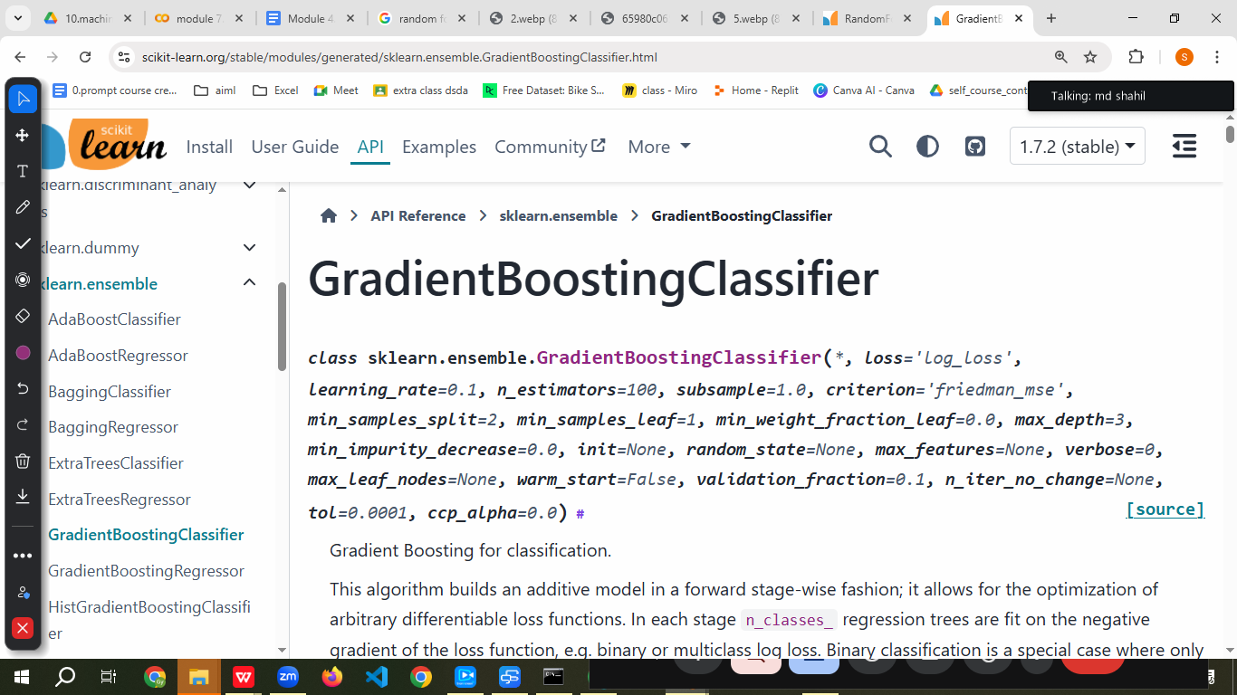

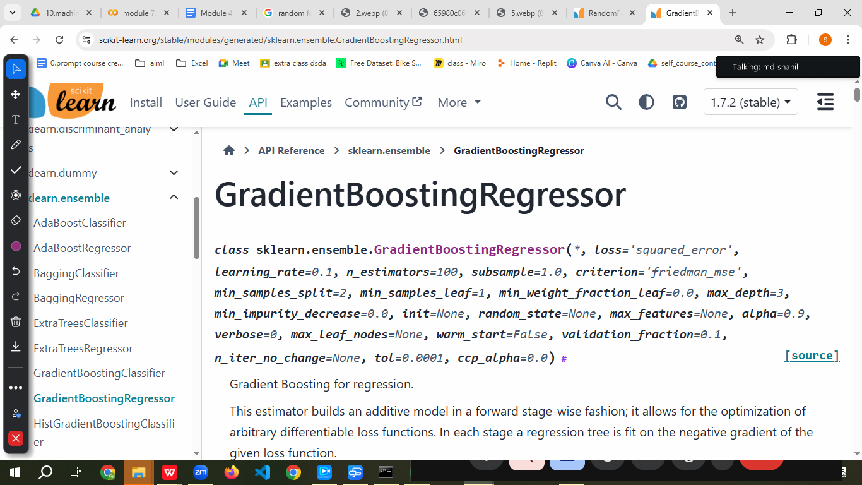

✅ Advantages:
- High accuracy
- Customizable loss functions

❌ Disadvantages:
- Slower training
- Sensitive to overfitting

📈 Use Case:
Ranking systems, insurance claim prediction, click-through rate prediction

📍 When to Use:
When performance is more important than speed

🚧 Limitations:
- Needs careful tuning
🔁 Alternative: Use XGBoost or LightGBM (faster, optimized)

✅ 4. XGBoost (Extreme Gradient Boosting)

https://xgboost.readthedocs.io/en/stable/tutorials/model.html
https://xgboost.readthedocs.io/en/stable/parameter.html
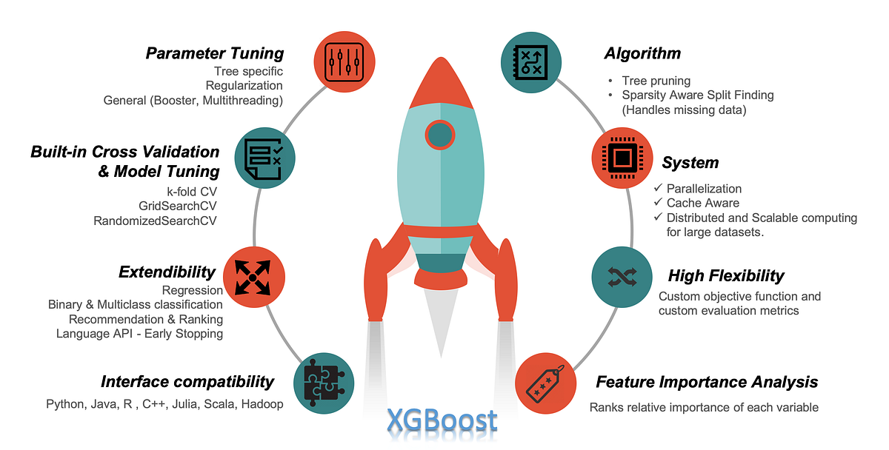

📘 Definition:
An optimized version of gradient boosting with regularization, parallelization, and tree pruning.

🧠 Intuition:
Efficiently builds additive models using optimized trees.
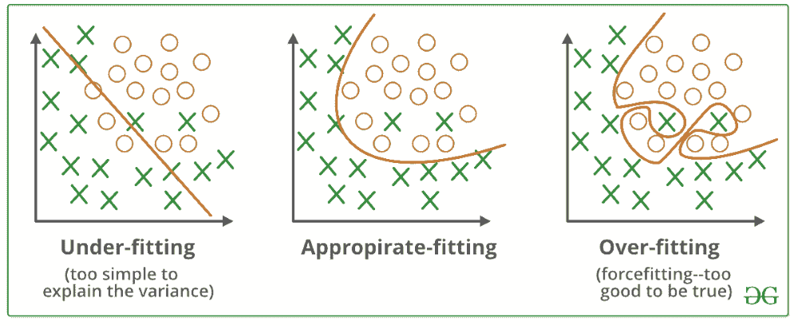
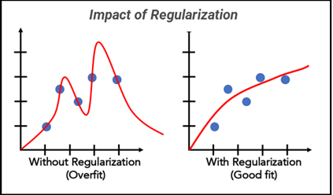
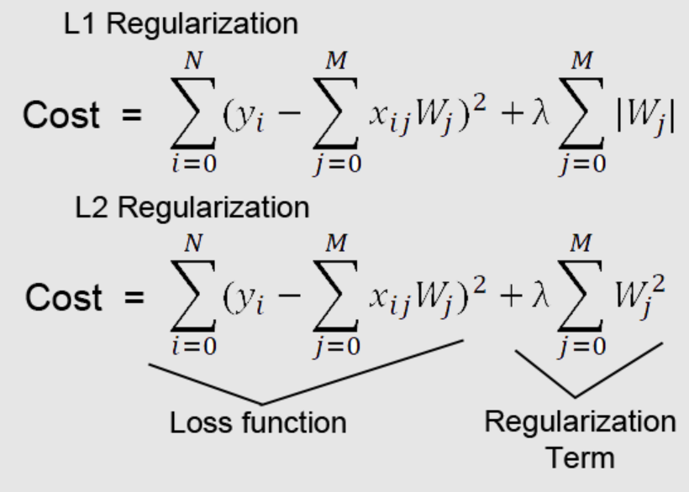
https://www.analyticsvidhya.com/blog/2016/03/complete-guide-parameter-tuning-xgboost-with-codes-python/

🧪 Code:
from xgboost import XGBClassifier, XGBRegressor

clf = XGBClassifier()
reg = XGBRegressor()

✅ Advantages:
- Faster than standard GBM
- Built-in regularization
- Handles missing data

❌ Disadvantages:
- More complex
- Needs tuning

📈 Use Case:
Kaggle competitions, fraud detection, time series

📍 When to Use:
When speed, scalability, and accuracy are required

🚧 Limitations:
- May still overfit
🔁 Alternative: Try CatBoost for categorical data or LightGBM for even faster performance

✅ 5. LightGBM

https://lightgbm.readthedocs.io/en/stable/
https://lightgbm.readthedocs.io/en/latest/Parameters.html

📘 Definition:
Boosting framework using leaf-wise tree growth for faster training.

🧠 Intuition:
Grows trees vertically (best leaf-first), which reduces loss faster.

🧪 Code:
from lightgbm import LGBMClassifier, LGBMRegressor

clf = LGBMClassifier()
reg = LGBMRegressor()

✅ Advantages:
- Very fast
- Handles large datasets and categorical features

❌ Disadvantages:
- Can overfit
- Leaf-wise growth may cause instability on small data

📈 Use Case:
High-frequency trading, recommender systems

📍 When to Use:
When working with large tabular datasets

✅ 6. CatBoost
https://catboost.ai/

📘 Definition:
Gradient boosting framework optimized for categorical features, with built-in encoding.

🧠 Intuition:
Uses ordered boosting and efficient handling of categoricals.

🧪 Code:
from catboost import CatBoostClassifier, CatBoostRegressor

clf = CatBoostClassifier(verbose=0)
reg = CatBoostRegressor(verbose=0)

✅ Advantages:
- Best with categorical data
- High accuracy
- Less hyperparameter tuning needed

❌ Disadvantages:
- Slower than LightGBM
- Heavier model

📈 Use Case:
Banking, telecom churn, health insurance

📍 When to Use:
When data has many categorical features

✅ 7. Stacking (Model Ensembling)
https://scikit-learn.org/stable/modules/ensemble.html#stacking

📘 Definition:
Combines predictions of multiple base models using a meta-model (e.g., linear regression, XGBoost).

🧠 Intuition:
Meta-model learns which base model to trust more.

🧪 Code:
from sklearn.ensemble import StackingClassifier, StackingRegressor
from sklearn.linear_model import LogisticRegression
from sklearn.tree import DecisionTreeClassifier
from sklearn.svm import SVR

# Example for classification
clf = StackingClassifier(
estimators=[('dt', DecisionTreeClassifier()), ('lr', LogisticRegression())],
final_estimator=LogisticRegression()
)

# Example for regression
reg = StackingRegressor(
estimators=[('rf', RandomForestRegressor()), ('svr', SVR())],
final_estimator=LinearRegression()
)
reg.fit()

✅ Advantages:
- Combines strengths of different models
- Better generalization

❌ Disadvantages:
- Complex
- Risk of overfitting if not done carefully

📈 Use Case:
Top-tier competitions, credit scoring, sales forecasting

📍 When to Use:
When you want to mix diverse models for best performance

🚧 Limitations:
- Computational cost
🔁 Alternative: Use bagging/boosting if interpretability is more important

🧩 Summary Table
Ensemble Method | Core Type | Handles Cat Features | Accuracy | Speed | Overfitting Control | Use When
Random Forest | Bagging | ❌ (need encoding) | High | Medium | ✅ | General use, interpretability needed
AdaBoost | Boosting | ❌ | Medium | Medium | ❌ | Simple and effective boosting
Gradient Boost | Boosting | ❌ | High | Slow | ❌ | Best accuracy needed
XGBoost | Boosting | ❌ | 🔥 Very High | Fast | ✅ | Large structured datasets
LightGBM | Boosting | ✅ | 🔥🔥 Very High | 🔥🔥 Very Fast | ✅ | Huge datasets with speed constraint
CatBoost | Boosting | ✅✅ Best | 🔥🔥 High | Medium | ✅ | Categorical-heavy datasets
Stacking | Ensemble | Based on base models | 🔥 High | Medium | ❌ (can overfit) | When you want to ensemble diverse models

# Ensemble Models on Classification and Regression Datasets (with XGBoost, LightGBM, CatBoost)

import pandas as pd
from sklearn.datasets import load_breast_cancer, load_boston
from sklearn.model_selection import train_test_split
from sklearn.preprocessing import StandardScaler
from sklearn.metrics import accuracy_score, r2_score
from sklearn.ensemble import (
RandomForestClassifier, AdaBoostClassifier, GradientBoostingClassifier,
RandomForestRegressor, AdaBoostRegressor, GradientBoostingRegressor,
StackingClassifier, StackingRegressor
)
from sklearn.linear_model import LogisticRegression, LinearRegression
from sklearn.tree import DecisionTreeClassifier
from sklearn.svm import SVR

# External libraries for advanced boosting
from xgboost import XGBClassifier, XGBRegressor
from lightgbm import LGBMClassifier, LGBMRegressor
from catboost import CatBoostClassifier, CatBoostRegressor

# Load classification dataset
cancer = load_breast_cancer()
X_cls, y_cls = cancer.data, cancer.target
X_cls_train, X_cls_test, y_cls_train, y_cls_test = train_test_split(X_cls, y_cls, test_size=0.2, random_state=42)

# Load regression dataset (Boston Housing)
boston = load_boston()
X_reg, y_reg = boston.data, boston.target
scaler = StandardScaler()
X_reg_scaled = scaler.fit_transform(X_reg)
X_reg_train, X_reg_test, y_reg_train, y_reg_test = train_test_split(X_reg_scaled, y_reg, test_size=0.2, random_state=42)

# Define ensemble models for classification
classifiers = {
"Random Forest": RandomForestClassifier(),
"AdaBoost": AdaBoostClassifier(),
"Gradient Boosting": GradientBoostingClassifier(),
"XGBoost": XGBClassifier(use_label_encoder=False, eval_metric='logloss'),
"LightGBM": LGBMClassifier(),
"CatBoost": CatBoostClassifier(verbose=0),
"Stacking": StackingClassifier(
estimators=[
('dt', DecisionTreeClassifier()),
('lr', LogisticRegression(max_iter=1000))
],
final_estimator=LogisticRegression(max_iter=1000)
)
}

# Define ensemble models for regression
regressors = {
"Random Forest": RandomForestRegressor(),
"AdaBoost": AdaBoostRegressor(),
"Gradient Boosting": GradientBoostingRegressor(),
"XGBoost": XGBRegressor(),
"LightGBM": LGBMRegressor(),
"CatBoost": CatBoostRegressor(verbose=0),
"Stacking": StackingRegressor(
estimators=[
('rf', RandomForestRegressor()),
('svr', SVR())
],
final_estimator=LinearRegression()
)
}

# Evaluate classification models
cls_results = {}
for name, model in classifiers.items():
model.fit(X_cls_train, y_cls_train)
preds = model.predict(X_cls_test)
acc = accuracy_score(y_cls_test, preds)
cls_results[name] = acc

# Evaluate regression models
reg_results = {}
for name, model in regressors.items():
model.fit(X_reg_train, y_reg_train)
preds = model.predict(X_reg_test)
score = r2_score(y_reg_test, preds)
reg_results[name] = score

# Display results
print("\nClassification Results (Accuracy):")
for name, acc in cls_results.items():
print(f"{name}: {acc * 100:.2f}%")

print("\nRegression Results (R2 Score):")
for name, score in reg_results.items():
print(f"{name}: {score:.4f}")

Ensemble methods, while powerful, can fail due to issues like computational cost, model complexity, and difficulty in interpreting results. To overcome these challenges, strategies like optimizing model selection, leveraging simpler ensemble techniques, and improving data quality are crucial.
Common Failure Points and Solutions:
- High Computational Cost:
Ensemble methods, especially those using complex models, can be computationally expensive.
  - Solution: Consider simpler ensemble techniques like bagging or explore model selection to identify the most efficient base learners.

- Complexity and Interpretability:
Ensembles can be difficult to interpret due to the combination of multiple models.
  - Solution: Prioritize simpler ensemble methods like random forests or focus on techniques that offer some level of interpretability, like SHAP values for gradient boosting.

- Data Quality Issues:
Poor data quality can negatively impact the performance of all models, including ensembles.
  - Solution: Focus on data cleaning, preprocessing, and feature engineering to improve data quality. Consider using robust ensemble methods that are less sensitive to outliers.

- Overfitting/Underfitting:
Like any machine learning model, ensembles can suffer from overfitting or underfitting.
  - Solution: Use appropriate regularization techniques, cross-validation, and model selection strategies to prevent overfitting. Address underfitting by increasing model complexity or using more advanced ensemble techniques.

- Inadequate Diversity:
If the individual models in the ensemble are too similar, the ensemble might not provide significant improvements over a single model.
  - Solution: Choose diverse base models or use techniques like boosting that encourage diversity by focusing on difficult-to-classify examples.

- Poor Base Model Selection:
The performance of an ensemble is heavily dependent on the quality of the base models.
  - Solution: Carefully select and tune the base models. Consider using a variety of models and evaluating their performance individually before combining them in an ensemble.

General Strategies for Improving Ensemble Performance:
- Boosting:
Boosting techniques iteratively train models, focusing on misclassified instances from previous models.
- Bagging:
Bagging trains multiple models independently on different subsets of the data and combines their predictions.
- Stacking:
Stacking combines multiple models using another machine learning algorithm to learn how to best combine their predictions.
- Random Forests:
A popular bagging method that uses decision trees as base models.
- Gradient Boosting Machines:
A boosting technique that builds decision trees sequentially, each correcting the errors of its predecessors.
Ensemble methods can fail when the individual models (or "weak learners") are not diverse enough, leading to similar predictions and thus, a less effective ensemble. To overcome this, consider using different algorithms, adjusting hyperparameters, or employing techniques like stacking that combine diverse models with a meta-learner.
Here's a more detailed breakdown:
Where Ensemble Methods Can Fail:
- Lack of Diversity:
If the individual models in an ensemble are trained on similar data or use the same algorithm, they will likely produce similar predictions. This reduces the benefit of combining them, as the ensemble essentially ends up relying on a single model's output.
- Overfitting to Training Data:
If the individual models overfit to the training data, the ensemble might also overfit, leading to poor generalization on unseen data.
- Poor Choice of Base Models:
If the individual models are not well-suited for the specific problem or are poorly trained, their combined predictions may not be accurate.
- Computationally Expensive:
Building and training ensembles can be computationally expensive, especially with large datasets and complex models.
Overcoming Failures with Different Models:
- 1. Introduce Diversity:
  - Different Algorithms: Use a mix of algorithms (e.g., decision trees, neural networks, support vector machines) as base models in your ensemble.

  - Hyperparameter Tuning: Optimize the hyperparameters of each individual model to find the best configuration for that specific algorithm.

  - Feature Engineering: Explore different feature sets for each model to encourage diverse perspectives on the data.

- 2. Use Stacking:
  - Meta-Learner: Stacked generalization involves training a meta-learner (another machine learning model) on the predictions of the base models.

  - Improved Generalization: This approach can lead to better generalization by allowing the meta-learner to weigh the predictions of the base models appropriately.

- 3. Regularization Techniques:
  - Reduce Overfitting: Employ regularization techniques (e.g., L1 or L2 regularization, dropout) to prevent individual models from overfitting and improve their generalization ability.

- 4. Consider Boosting:
  - Sequential Training: Boosting algorithms train models sequentially, focusing on examples that were misclassified by previous models.

  - Adaptive Weighting: Boosting algorithms adaptively adjust the weights of training examples, focusing on the more difficult instances.

- 5. Ensemble Selection:
  - Choose Best Performing Models: Instead of using all models, select a subset of the best-performing models based on their performance on a validation set.

  - Reduced Complexity: This approach can reduce the computational cost of the ensemble and potentially improve its performance.
=====================================================================

Ensemble methods, while powerful, can struggle with highly complex, unstructured data or when individual models are too weak or biased. In such cases, neural networks can offer an alternative, particularly those designed for deep learning. Ensemble methods may also underperform if the individual models are too similar or if the data is not diverse enough to provide meaningful variations.
Here's a breakdown of potential pitfalls and solutions:
Where Ensemble Methods Fail:
- High Dimensionality and Complex Relationships:
When dealing with very high-dimensional data (many features) or intricate, non-linear relationships, ensemble methods might not capture the underlying patterns as effectively as neural networks, according to Meegle.com.
- Weak or Overly Biased Base Learners:
If the individual models within the ensemble are consistently making similar errors, the ensemble's diversity is limited, and it may not improve upon the performance of a single strong learner.
- Lack of Feature Diversity:
If the base models are all trained on the same or very similar feature sets, the ensemble's ability to generalize to new data can be compromised.
- Computational Cost:
Training large ensembles, especially with complex models like deep neural networks, can be computationally expensive and time-consuming, according to various sources.
Overcoming Challenges with Neural Networks:
- Deep Learning for Complex Patterns:
Neural networks, particularly deep learning models, can learn complex, hierarchical representations of data, allowing them to capture intricate patterns that simpler models or ensemble methods might miss, says Machine Learning Mastery.
- Feature Engineering and Representation Learning:
Neural networks can learn useful feature representations from raw data, potentially reducing the need for extensive manual feature engineering, which can be a strength when dealing with unstructured data.
- Ensemble Neural Networks:
As an alternative, consider using an ensemble of neural networks. This involves training multiple neural networks and then combining their predictions.
- Regularization and Dropout:
Techniques like regularization (L1, L2) and dropout can help prevent overfitting, a common problem when training deep neural networks.
- Architectural Choices:
Experiment with different neural network architectures (e.g., CNNs for image data, RNNs for sequential data) to find the one best suited for your specific task.
When to Consider Neural Networks:
- Unstructured Data: Neural networks excel when dealing with unstructured data like images, text, or audio, where ensemble methods might struggle, according to Meegle.com.

- High-Dimensional Data: Neural networks can handle large numbers of features effectively.

- Complex Relationships: When the relationship between inputs and outputs is highly non-linear, neural networks can be a good choice.
In essence: Ensemble methods are powerful for many problems, but neural networks can be a superior choice when dealing with very complex data, unstructured data, or when individual models in an ensemble are not diverse enough. Ensemble methods can also be used within the realm of neural networks, creating ensemble neural networks.
FINE TUNE THE MODELS

# Ensemble Models on Classification and Regression Datasets (with XGBoost, LightGBM, CatBoost, Evaluation, and Fine-tuning)

import pandas as pd
from sklearn.datasets import load_breast_cancer, load_boston
from sklearn.model_selection import train_test_split, GridSearchCV, cross_val_score
from sklearn.preprocessing import StandardScaler
from sklearn.metrics import accuracy_score, r2_score, mean_squared_error, confusion_matrix, classification_report
from sklearn.ensemble import (
RandomForestClassifier, AdaBoostClassifier, GradientBoostingClassifier,
RandomForestRegressor, AdaBoostRegressor, GradientBoostingRegressor,
StackingClassifier, StackingRegressor
)
from sklearn.linear_model import LogisticRegression, LinearRegression
from sklearn.tree import DecisionTreeClassifier
from sklearn.svm import SVR

# External libraries for advanced boosting
from xgboost import XGBClassifier, XGBRegressor
from lightgbm import LGBMClassifier, LGBMRegressor
from catboost import CatBoostClassifier, CatBoostRegressor

# Load classification dataset
cancer = load_breast_cancer()
X_cls, y_cls = cancer.data, cancer.target
X_cls_train, X_cls_test, y_cls_train, y_cls_test = train_test_split(X_cls, y_cls, test_size=0.2, random_state=42)

# Load regression dataset (Boston Housing)
boston = load_boston()
X_reg, y_reg = boston.data, boston.target
scaler = StandardScaler()
X_reg_scaled = scaler.fit_transform(X_reg)
X_reg_train, X_reg_test, y_reg_train, y_reg_test = train_test_split(X_reg_scaled, y_reg, test_size=0.2, random_state=42)

# Define ensemble models for classification
classifiers = {
"Random Forest": RandomForestClassifier(),
"AdaBoost": AdaBoostClassifier(),
"Gradient Boosting": GradientBoostingClassifier(),
"XGBoost": XGBClassifier(use_label_encoder=False, eval_metric='logloss'),
"LightGBM": LGBMClassifier(),
"CatBoost": CatBoostClassifier(verbose=0),
"Stacking": StackingClassifier(
estimators=[
('dt', DecisionTreeClassifier()),
('lr', LogisticRegression(max_iter=1000))
],
final_estimator=LogisticRegression(max_iter=1000)
)
}

# Define ensemble models for regression
regressors = {
"Random Forest": RandomForestRegressor(),
"AdaBoost": AdaBoostRegressor(),
"Gradient Boosting": GradientBoostingRegressor(),
"XGBoost": XGBRegressor(),
"LightGBM": LGBMRegressor(),
"CatBoost": CatBoostRegressor(verbose=0),
"Stacking": StackingRegressor(
estimators=[
('rf', RandomForestRegressor()),
('svr', SVR())
],
final_estimator=LinearRegression()
)
}

# Evaluate classification models
cls_results = {}
print("\nClassification Results:")
for name, model in classifiers.items():
scores = cross_val_score(model, X_cls_train, y_cls_train, cv=5)
model.fit(X_cls_train, y_cls_train)
preds = model.predict(X_cls_test)
acc = accuracy_score(y_cls_test, preds)
print(f"{name}:\n Accuracy: {acc * 100:.2f}%\n Cross-Validated Score: {scores.mean():.4f} ± {scores.std():.4f}")
print(" Classification Report:")
print(classification_report(y_cls_test, preds))
cls_results[name] = acc

# Evaluate regression models
reg_results = {}
print("\nRegression Results:")
for name, model in regressors.items():
scores = cross_val_score(model, X_reg_train, y_reg_train, cv=5, scoring='r2')
model.fit(X_reg_train, y_reg_train)
preds = model.predict(X_reg_test)
r2 = r2_score(y_reg_test, preds)
mse = mean_squared_error(y_reg_test, preds)
print(f"{name}:\n R2 Score: {r2:.4f}\n MSE: {mse:.2f}\n Cross-Validated Score: {scores.mean():.4f} ± {scores.std():.4f}")
reg_results[name] = r2

# Optional: Fine-tuning example for one model
print("\nFine-tuning RandomForestClassifier:")
param_grid = {
'n_estimators': [50, 100],
'max_depth': [None, 10, 20],
'min_samples_split': [2, 5]
}
grid_search = GridSearchCV(RandomForestClassifier(), param_grid, cv=3, scoring='accuracy')
grid_search.fit(X_cls_train, y_cls_train)
print("Best Parameters:", grid_search.best_params_)
print("Best Score:", grid_search.best_score_)

# Display summarized results
print("\nFinal Summary:")
print("\nClassification Accuracies:")
for name, acc in cls_results.items():
print(f"{name}: {acc * 100:.2f}%")

print("\nRegression R2 Scores:")
for name, score in reg_results.items():
print(f"{name}: {score:.4f}")

